2022 - 2024
Sustainability Plan

Focused Leadership Group
April 2022

Purpose
We empower local business!
We will:
    - Promote a local business mindset
    - Help existing business thrive
    - Support economic development initiatives
    - Influence public policy for a healthy business climate

Organizational Health Pillars
The organizational pillars help provide balance between strategy and operational sustainability and ultimately reflect the most critical aspects of the St. Paul Chamber’s overall health and ongoing viability. Our annual operational and strategic priorities should encompass each of these pillars and the desired outcomes within.

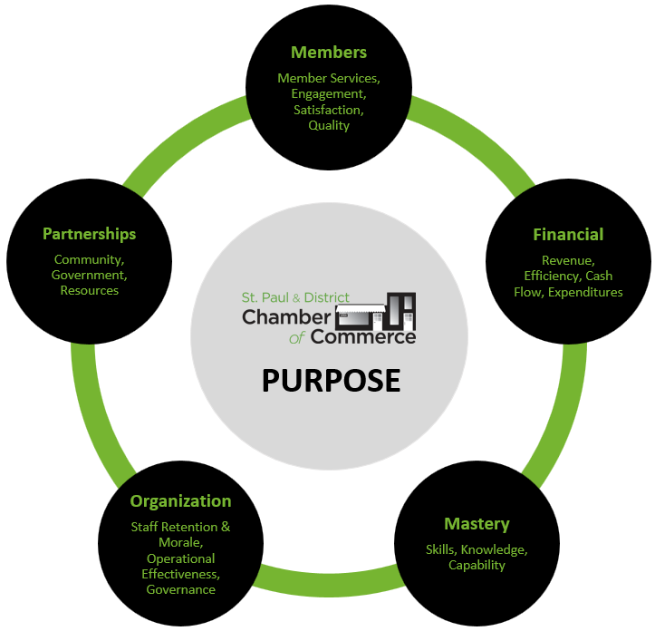

Desired Outcomes for Each Pillar
The following outcomes serve as a foundational framework for ongoing organizational success and sustainability EACH YEAR. These outcomes are the minimum required for the St. Paul Chamber to be healthy and in a position to achieve its Purpose/Mandate.

Members | - Relationships with our membership is collaborative and positive.  - Opportunities for members to engage exist.  - Each member is personally visited once per year.  - Perspective members are visited with and educated on benefits of Chamber membership.  - Membership summaries are created, reviewed, and acted upon accordingly.  - An effective membership engagement plan exists and is implemented/evaluated.  - Exit interviews are conducted with non-renewing members. Termination trends are monitored and acted upon.  - Community-based Chamber events are successfully coordinated (sponsorships, program, public participation).  - Opportunities to benefit members and our business community are researched and successfully implemented.  - All events are debriefed and evaluated to determine member benefit and improvement measures.
Financial | - Chambers Plan Benefits plan is promoted within business community to maximize funding.  - A balanced budget exists every month.  - A full annual budget is reviewed and approved by the Board.  - Meet reporting conditions of any funders and/or sponsors.  - Spending is in accordance with pre-set guidelines.  - Clear explanation/evidence exists for all variances on budget.  - Coded invoices attached to cheques that need to be signed.  - All employee/employer source deductions are paid in a timely fashion according to Revenue Canada.  - Board member Director Liability insurance is in place and up to date.  - Monthly system in place (Spreadsheet) to track revenue vs. expenditures.  - Surplus money is planned for, tracked, and predicted for in advance of year end.  - System in place for on-site cash usage & tracking.  - Expenditure plan & Authorization is in place/followed.  - Capital replacement & maintenance plan exists and is followed regularly.  - Proper accounting principles are regularly followed/practised.  - Funding assistance is secured for summer counsellor positions and compliance with funding requirements is adhered.  - All utility/service rates used by the Chamber are competitive.  - Committees (and the Board) are aware of and understand respective specific budgets.
Organization | - An annual operational plan with priorities and actions exists to guide the work of the Board and staff.  - Organizational by-laws, policies exist, comply with all required legislation, and are reviewed at least semi-annually.  - Effective and professional working relationships exist between the Board and all staff.  - Low turnover rates in relation to industry standards exist with Chamber staff.  - Board Committees are successfully engaged.  - Project coordination meet desired outcomes and timelines.  - Organizational structural efficiency is regularly reviewed  - Organizational (staff thru to board) culture is positive and productive.  - Compensation is competitive (to industry) & fair across organization.  - Staff are clearly aware of organization health pillar outcomes and proficient with their respective responsibility towards meeting them.  - All staff are actively engaged in the successful operations and initiatives of the Chamber.  - Confidentiality of member dealings is upheld.  - Performance of all staff are evaluated annually against organizational and positional outcomes.  - Board Committee structure exists and is functional.
Community/ Partnerships | - The Chamber brand is protected, visible and positive.  - Relationships with the larger business community is collaborative and positive.  - Active participation in, and relationship with the ACC and CCC and their initiative exists.  - New relationships are explored and fostered.  - Relationships with local/regional representatives of all levels of government are positive and collaborative.  - Positive relationships exist with all community groups and provide mutual benefit.  - Positive relationships exist and information is regularly shared with other local Chambers in the surrounding area and province.  - Executive Director is aware of all major community news that affect the Chamber and apprises the Board on a timely fashion.
Mastery | - An employee development plan exists, is implemented, and is renewed semi-annually and meets the needs of our members and the Chamber as a whole.  - Training on current and related sector knowledge is ongoing as necessary.  - The Board completes an annual self assessment of its functionality and performance.  - The Executive Director possess the necessary skills/expertise/background/current knowledge to effectively lead the Chamber.

