GOVERNANCE
Roles & Limitations
2022-2024
Facilitated by:
CHAMBER GOVERNANCE – Functional Overview
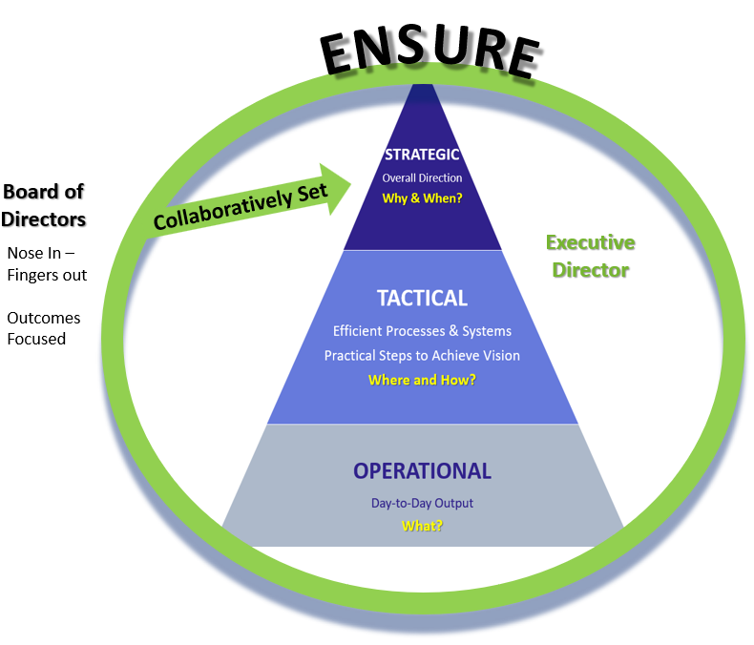

HYBRID GOVERNANCE MODEL (overview)
The Board has chosen to follow a hybrid model of governance meaning that you have a role in all four of the following areas.
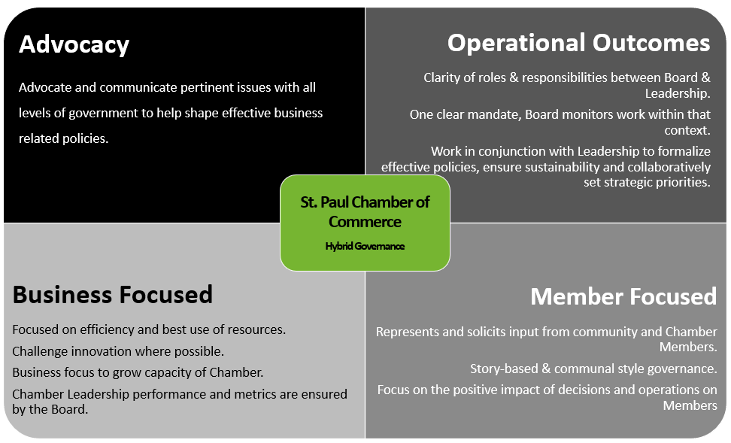

GOVERNANCE RESPONSIBILITIES AND LIMITATIONS
Board of Directors | Governance Responsibility | Executive Director
- Clearly understand the nature of services (sets & protects mandate) and ensures that services are of high quality.  - Govern Chamber on behalf of the members according to its Chamber mandate and values. | Stakeholder Benefit | - Provide regular updates on service successes and challenges.  - Balance stakeholder interests with those of the Chamber.  - Provide recommendations on rationale for large scale, or large impact changes to services.  - Member and community events are attended to represent the Chamber.
- Ensures mission and mandate are never compromised.  - Respectful of current priorities & approves all newly developed policies.  - Ensures comprehensive grievance (members) processes and policies are followed.  - Conducts annual performance review on Executive Director complete with compensation review.  - Is aware of and provides direction (according to legal advice) on legal matters that can negatively affect the Chamber. Ensures the Chamber is protected.  - Ensure a Risk Management and business continuity plan is in place. | Fiduciary: Chamber Stewardship | - Hold all self and staff accountable to mandate.  - Make recommendations where necessary to amend mandate as may be required.  - Monitors the ongoing health and sustainability of the Chamber.
- Ensures Executive Committee of the Board is aligned with Board on Chamber strategic direction.  - Develops strategic priorities in concert with Executive Director. | Strategic Evolution & Growth | - Works with Board to review and evaluate potential growth & development opportunities.  - Develops strategic priorities in concert with Board and ensures alignment with Chamber staff.
- Ensures investments into services and are thoroughly planned.  - Set financial commitment levels for Executive Director.  - Ensure spending parameters are in place.  - Ensures sound auditing processes are in place. | Financial Viability | - Utilizes funds responsibly to maximize resources and initiatives.  - Brings financial concerns to the attention of the Board.
- Ensure an operational sustainability plan is in place complete with health pillars and outcomes; and is reviewed quarterly.  - Ensures effective Committee’s are in place that follow Terms of Reference. | Operational Efficiency | - Keeps the Board aware of pressures that can limit the effectiveness & efficiency of the Chamber
- Provide support for political lobbying where required.  - President acts as the official voice of the Chamber for all politically related matters in collaboration with Executive Director.  - All political representation is non-partisan. | Ambassadorial & Advocacy | - Acts as the official Chamber voice for all external matters not political. Political voice is as directed as the President.  - All political representation is non-partisan.
- Ensures member feedback & service improvement processes are in place.  - Ensures metrics are in place to measure to meet required annual operating outcomes.  - Ensure ongoing continuous improvement processes exist. | Reflection & Assessment | - Ensures member feedback & service improvement processes are in place.
- Scrutinizes and approves all nominations/appointments.  - The President will ensure the integrity of the Board’s process.  - Board committees can be created by collective approval of the Board. The existence and charge of any Committee (standing or ad hoc) will be represented by an official Terms of Reference as approved by the Board. | Board Development | - Has primary coordination and oversight for Board recruitment

GOVERNANCE – Limitations
Board of Directors | Executive Director
- The Board’s sole connection to the operations, its achievements and conduct will be through the Executive Director.  - Only the Executive Committee of the Board acting as a collective body can be involved in matters of employment, termination, discipline or change in the conditions of employment of the Executive Director.  - Decisions, evaluations or instructions of individual Board Members to the Executive Director or staff are not binding unless the Board as a collective have authorized the authority.  - Individual Board members will not act, represent the Chamber, or make decisions independently of the Board’s approval and Executive Director involvement.  - The Board will direct the Executive Director to achieve specific mutually agreed upon results for the Chamber and ensure relevant metrics exist for review.  - Individual Board members will ensure a climate of positive collaboration, decorum and common outcomes-focus at all times.  - Individual Board members will avoid any conflict of interest whether real or perceived that supersedes their responsibility to our Chamber. Potential conflict shall be declared and noted in minutes. The member will remove themselves from all related discussions, votes and decisions. | - All Board authority is delegated to the Executive Director so that accountability of staff is considered to be accountability to the Executive Director.  - As long as the Executive Director uses reasonable interpretation of the Chamber’s mandate, resources and policies, they are authorized to make all operational decisions, take all actions and establish practices to progress and safeguard the Chamber.  - The Executive Director shall not cause or permit any activity or practice that is illegal, imprudent or in violation of commonly accepted business practices, regulations or laws.  - The Executive Director will ensure a climate of positive collaboration and common outcomes-focus at all times.  - The Executive Director will not alter the mandate or course of services without the knowledge, discussion and approval of the Board of Directors.  - Budgeting and operational finances shall not deviate from mutually agreed upon priorities and direction with the Board of Directors.  - The Executive Director will keep the Board apprised of the details of all legal matters unto the Chamber and will not act independently of advice from appropriate legal counsel an/or collective Board decision.  - The Executive Director shall not cause or allow fiscal jeopardy or material deviation of major expenditures that deviate from the current mandate. This includes expended funds cannot exceed revenues in any given fiscal year. Investments shall not be made without the knowledge and collective approval of the Board.  - The Executive Director will ensure all Chamber assets are protected, adequately maintained and exposures to risk are mitigated.  - The Executive Director will not change their compensation and benefits without the written permission (and related specifics) by the Executive Committee of the Board.  - The Executive Director shall not withhold, impede or misrepresent information and facts relevant to the Board’s ability and responsibility to take appropriate actions or make decisions.

