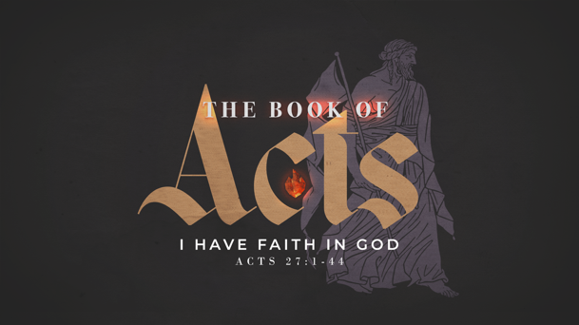
Life Group Questions / February 8, 2026

The Book of Acts
68 – I have faith in God
Acts 27:1-44

- Aside from your faith (which I hope you would say grounds you), what else brings settled-ness, stability, and a sense of security to your life? As you think about it, are any of them displacing faith in Christ for you?

- Does your faith inform the most mundane and ordinary aspects of your life? If not, why not? What could you do to introduce your faith to other aspects of your life?

- Have you ever experienced a truly “hopeless” situation? What turned it around for you? What is the only truly hopeless situation?

- What does it take for a Christian to believe what Elizabeth Elliot believed when she said, “The deepest things that I have learned in my own life have come from the deepest suffering. And out of the deepest waters and the hottest fires have come the deepest things that I know about God.” (from Suffering is Never for Nothing)

- How did Paul embrace the opportunity that God gave him to lead during the shipwreck crisis? How can you use that in your own life?

- Why is the Lord’s Table so critical to our understanding and acceptance of suffering?

- Write this definition in the front of your Bible where it is handy: “Faith is believing the Word of God and acting upon it no matter how I feel knowing God promises a good result.”

