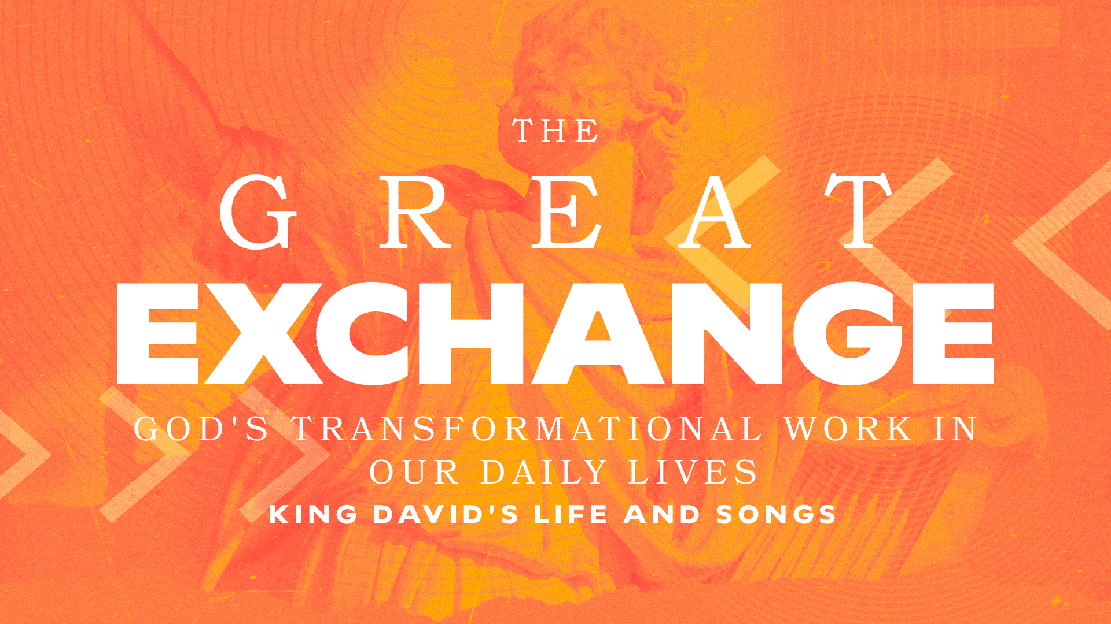

From Defeat to Faith Part 2
Psalm 54 // Todd Dugard
November 10, 2024

My faith will be built as I…
…plead my case to God (v. 1-3)
…confess my trust in God (v. 4)
…lean on the justice of God (v. 5)
…commit to life with God (v. 6-7)

GROUP STUDY QUESTIONS

- The true Christian life of faith requires individual intentionality.
  - In what ways have you been intentional with your faith during this season?
  - In what areas are you struggling or falling short?
  - What forms of accountability within your small group can be established to maintain intentionality?
- David pleads with God concerning his current situation, yet some of us as Christians don't feel the need to bring our non-salvation concerns before God because we haven't yet reached the end of ourselves; we lack the necessary humility.
Pastor Todd asks a series of questions:
Rather than plead with God, Do I…
…deny the trial?
…complain about the trial?
…wallow in the trial?
…rebel against the trial?
…ignore what he has said about trials in his Word?

  - What Scriptural truths can we hold onto to help us avoid these actions and walk in humility?
  - How can we express continual trust despite tough circumstances or seasons?

- Revelation 21:1-4 reminds us that God will wipe every tear from our eyes, that death will be no more, that there will be no mourning, no crying, no pain…for the former things have passed away.
  - How does this truth, along with David's heart in Psalm 54, strengthen our confidence in entrusting our lives to God?
  - How can we find the ability to praise God despite the trials we face in this life?

