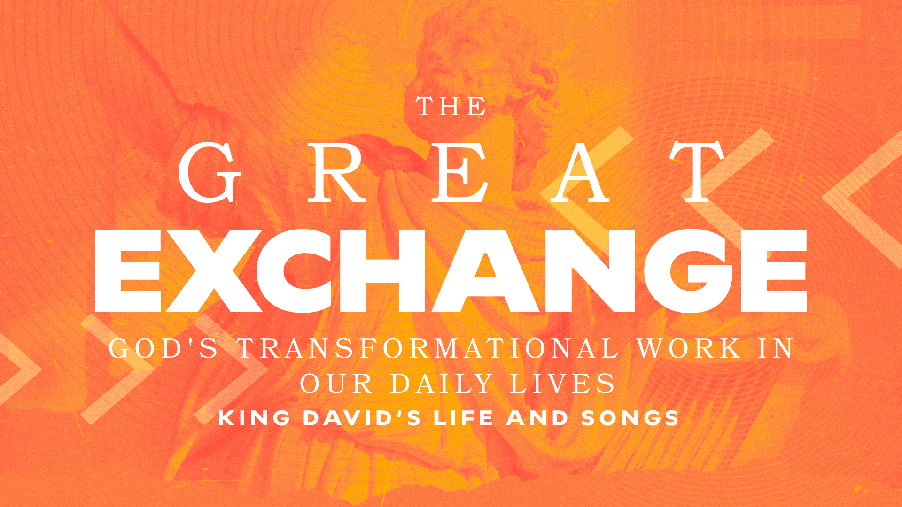

From Defeat to Faith Part 1
1 Samuel 23 // Todd Dugard
November 3, 2024

When it looks like I’m about to take a loss, God is simply increasing my faith by…
…expanding my wisdom (v. 1-5)
…building my trust (v. 6-14)
…encouraging my soul (v. 15-18)
…strengthening my resolve (v. 19-29)

GROUP STUDY QUESTIONS

- David believed the Word, acted upon what God said and pushed his emotions aside because he knew God had promised a good result.

  - How often do we say we believe, yet our actions say the opposite? Where does the disconnect come between spoken theology (what we say we believe) and lived out theology (what we actually do)?

  - How do we bridge that gap?

- Endurance (hupomone) is the capacity to continue to bear up under difficult circumstances.

  - Where have you experienced hardships that God used to strengthen your faith? Share with each other and discuss how this strengthened your resolve.

- God encourages David in 1 Samuel 23:15-18.

  - Talk about times where God has encouraged your soul in a time of need. How did he encourage you? Through a friend? Another believer? A sermon? A podcast? A prayer?

- As Pastor Todd reminded us, we need each other, but we cannot just be the friends that “pump up the tires” of others.

  - How can we be pointing our brothers and sisters in Christ towards him in this way?

