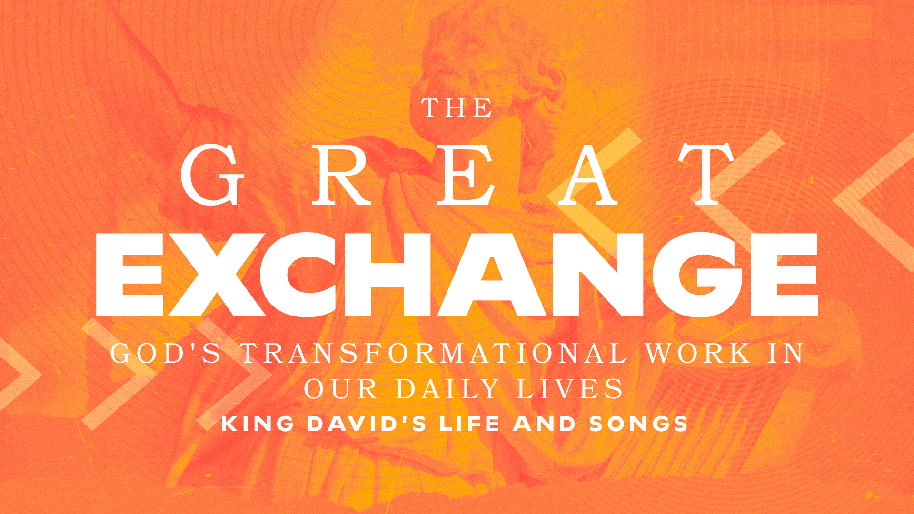

From Muddled to Gratitude Part 2
Psalm 34 // Todd Dugard
October 13, 2024

When I inevitably muddle up…
…I thank the Lord that he listens to me (34:1-3)
…I thank the Lord that he cares for me (34:4-7, 15-18)
…I thank the Lord that he teaches me (34:8-14)
…I thank the Lord for his promises to me (34:19-22)

GROUP STUDY QUESTIONS

James exhorts believers in James 1:2-4 to “count it all joy” when (not if!) we face trials of various kinds.

- Praise psalms express our natural orientation before God as regenerate believers. Lament psalms express our disorientation. When we are disoriented, we find ourselves in a state of confusion, or rather, a "muddle."

  - Thanksgiving psalms, such as Psalm 34 express our reorientation - a restoration of our hearts - standing in awe and reverence of God’s goodness, mercy and grace. Based upon what you have heard in this sermon, how is it that we can “count it all joy” when you are waist-deep in mud? What about when you are covered head-to-toe?

- In the end, David realizes it was God all along who got him out of Gath.

  - In hindsight, where have you seen God work in and through the times you took life into your own hands and got yourself into a mess? How will seeing this full-circle of reorientation help you grow in walking by faith and not by sight?

- Seeing the full circle of how God worked in and through David’s circumstances grants us the insight that even heroes of faith, like David, can fall.

  - The world is quick to mock Christians (and God) when they fail in faith and humility. How can we grow in blessing God through afflictions in order to witness well to the world?

While life is often muddled and messy, in the end it is supervised by God. We rest in the knowledge that things are not out of control and somehow God’s will and ways are being worked out.” (David Barker, This Poor Man Called, 53).

