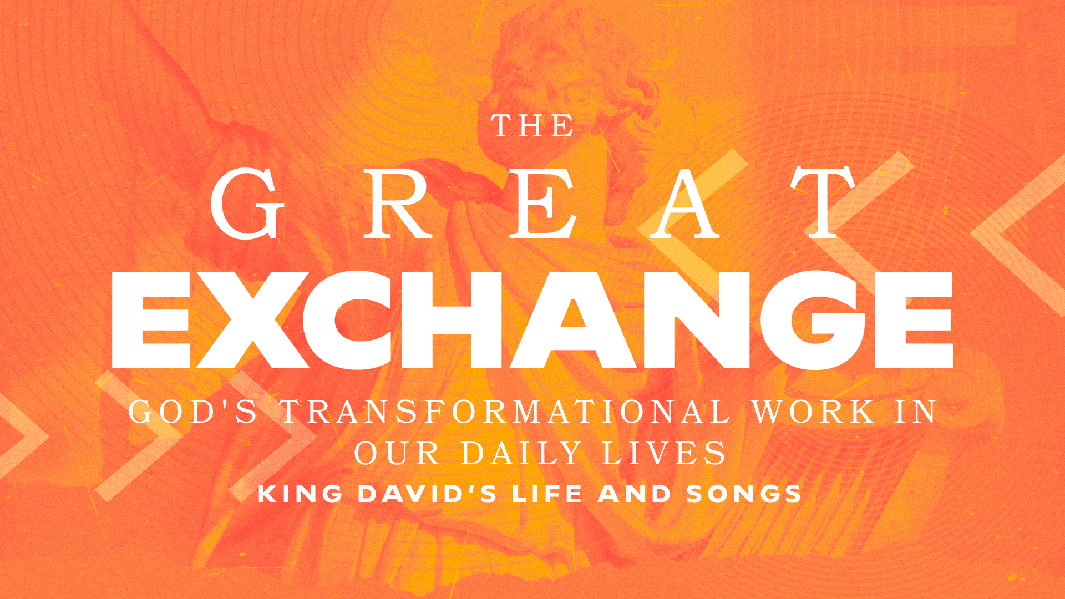

From muddled to gratitude Part 1
1 Samuel 21:10-15;22:1-5 // Todd Dugard
October 6, 2024

When life is muddled, will I see God at work…
…in establishing my identity? (21:10-11)
…in demonstrating his sovereignty? (21:12-13)
…in orchestrating the outcomes? (21:14-15; 22:1-5)

GROUP STUDY QUESTIONS

- Our fundamental identity is son or daughter or God. When we lose ourselves in earth-bound identities, such as education level, career choice, wealth, awards, achievements, marital status, gender, ethnicity or the like, we end up in places we aren’t meant to be. We, like David, end up muddled.

  - Compile a list of five things that are true about you in the world: spouse, parent, achievements, ethnicity, etc.

  - Now, compile a list of Scripture that reminds you of who you are (your identity) in Christ.

  - Pastor Todd granted us the “how” pertaining to what we must do in order not to get “stuck in the mud.” What was it?

  - Discuss the implications of the things that are true about you in the world, while rooted in your identity in Christ. How do you live this out?

- “Everything that is happening or has happened in your life is for a reason. It’s part of the plan in some way. Every win, every joy, every blessing, all the good…he’s had a reason for giving that to you. And every loss, every sorrow, every hardship, all the bad that’s come your way…he has a reason.” - Pastor Todd.

  - Our holy God providentially allows things to happen outside His plans for our lives (murder, adultery, anger, lust) to accomplish His good will in and through us. This is not easy to understand or accept. How does the sovereignty of God bring you peace when you have taken matters into your own hands and ended up in a mess like David?

  - What Scripture can you turn to, to help you remember this truth when you cannot see the bigger picture? (Ex: Romans 5:3-5).

“When you go through a trial, the sovereignty of God is the pillow upon which you lay your head.” - Charles Spurgeon.

